Цель: формирование представления учащихся о развитии рок-н рола в Америке;
Задачи:
узнать имена великих певцов рок – н – рола;
закрепить навыки работы с английским текстом;
воспитывать любовь к музыке.
Ход урока:
1.организационый момент.
Вначале урока звучит отрывок из песни “Ты моя мелодия” поет М. Магомаев.
1) T: Hello, children. I am glad to see you. Hello, dear quests. We are glad to see you, too. Today we have unusual lesson both an English lesson and Music lesson.
So, you listen the word MUSIC, and our topic is “Music in my life”. Today we shall speak about different styles in music, practice our listening, reading, speaking and writing.

2.речевая разминка. Беседа о музыке.
What is music? Do you often listen to music? To what kind of music? Does it make you happy? Can you play any musical instrument? Is a special musical training necessary to understand music? What kinds of music do you know? Do you like rock? What roc do you know?
What is the aim of our lesson today? What are we going to discuss today?

3. Answer this question:
What rock singers do you know? Do you know these rock American singers?
( Знаете ли вы этих рок певцов в Америке?)
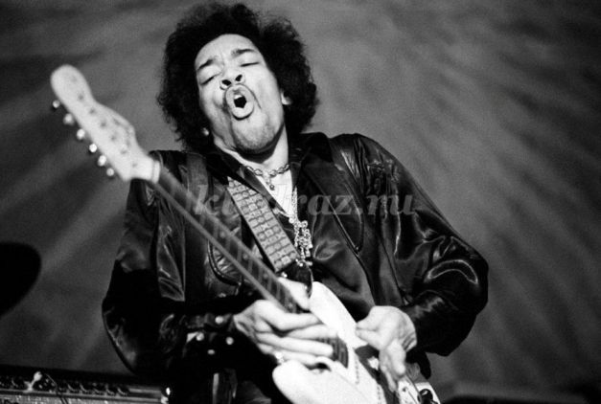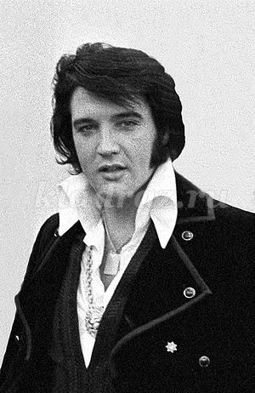
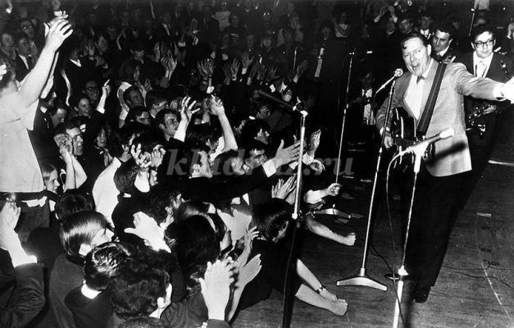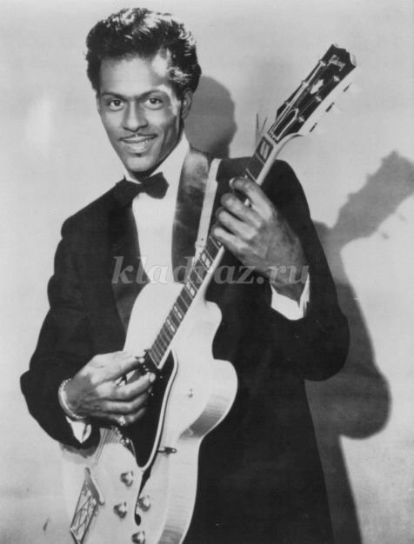
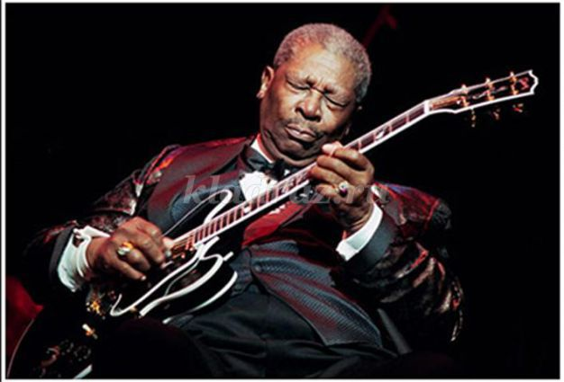
4. Актуализация ранее изученного лексического материала. Работа по тексту: “Teenagers and Rock-n- Roll”.
The 1950s were an exciting time for music in America. The economic problems of the 30 –s and the war of the 40-s were over. America was rich again. A new group of people became important – American teenagers. For the first time in history young people had money to spend. They had a new way of dressing, new hair styles and new dances.
In the early 50-s slow romantic songs were still popular. But teenagers wanted dance music with a good beat, and so they began to listen to R and B (rhythm and blues) on the black radio stations. A white disc jockey, Alan Freed, began to play R and B on the radio for white teenagers. He was the first person to call this new music “rock and roll”. The first white group to make a rock and roll hit record was Bill Halley and the Comets, with “Rock around the Clock”. Rock and Roll music had a strong dance beat. The musicians played electric guitars and the music was loud and fast. American teenagers loved it.
About the same time, the owner of Sun Record Company, Sam Phillips, said:“ If I could find a white man who had the Negro (black) sound and the Negro feel, I could make a billion dollars.” He found his wish in Elvis Preley? The king of rock and roll.
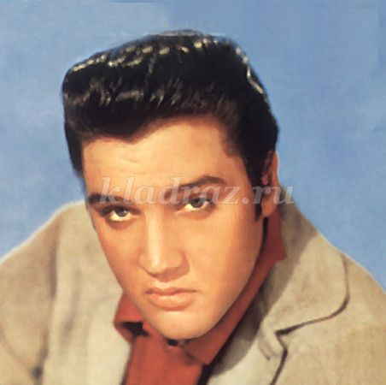
Elvis became a new American hero and young people copied his hair style, his dresses and his music.
On February 3, 1959 three famous rock and roll stars, Buddy Holly, the Big Popper and Richie Valens, died in a plane crash. As a result many people thought that rock and roll music had died too. But the music of the late 50 –s lived on. Rock and Pop from the 60-s to the 90-s grew out of this old rock and roll. As the song says,” Rock and roll is here to stay:
[a) Exercises:
1. How much did you understand?
Are these statements true or false?
(Эти утверждения верны или нет?)
a) The 1950s were an exciting time for music in America.
b) For the first time in history young people had money to spend.
c) In the early 50s slow romantic songs were still popular.
d) A white disc jockey, Alan Freed, began to play rhythm and blues on the radio for white teenagers.
e) American teenagers didn’t love rock and roll music.
f) Elvis Presley became a new American hero and young people copied his hair style, his dress and his music.
b) Can you answer these questions?
(ты можешь ответить на эти вопросы?)
a) Why were the 1950s an exciting time for music in America?
b) What group of people became important in the early 50s?
c) What did they begin to listen to on the black radio stations?
d) What music did teenagers want to dance to in the early 50s?
e) Who was the first person to call rhythm and blues music rock and roll?
f) What was the first white group to make a rock and roll hit record?
g) What kind of music was rock and roll?
h) Who was the king of rock and roll?
i) Why did Americans think that rock and roll music had died in 1959?
j) Did the music of the late 50s live on?
c) Do you know that? (Знаешь ли ты, что…)
T: Many people and young people are fond of music. Music teachers tell pupils about famous composers and teach to sing songs. Pupils prepare concerts, learn new songs and play different musical instruments:
What musical instruments do you know?

(инструменты) уч-ся читают: piano, trumpet, bass gitar, acoustic gitar, saxophone, violin, drums, BANJO.
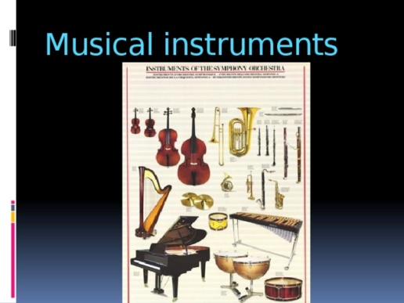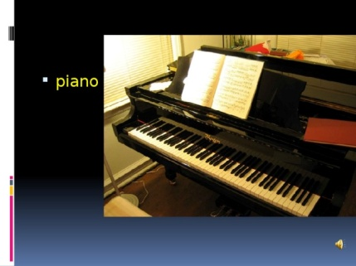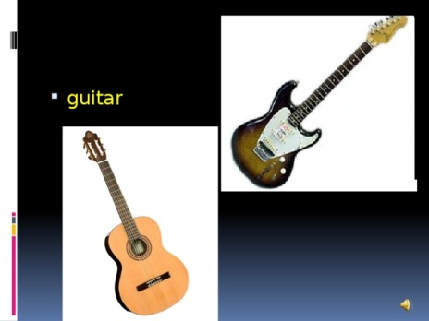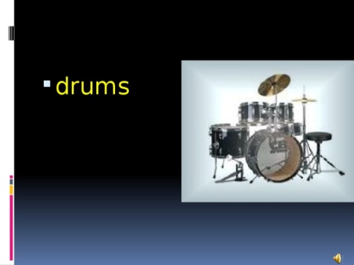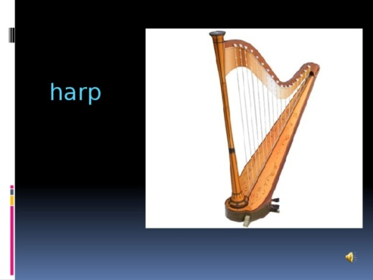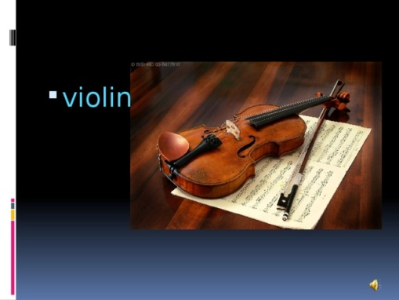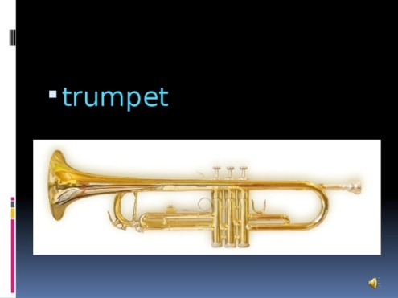

7. Минутка отдыха “Guess the singer”
Teacher: Are you tiered? Let’s have a break.
I have a surprise for you.
Let’s listen the famous singers and answer the question:
Who sings this song? (Учитель включает песни, ученики прослушивают и дают ответы)
Answers:
1. Dima Bilan
2. Rihanna
4. P.Gagarina

8. Активизация лексики в речи «Интервью».
Teacher: There are different kinds of music, but tastes differ, you know. I want to know what music styles you prefer? For this task I asked … to be our class correspondent. Please come here… and ask your classmates about their favourite music styles.
(Один из учащихся выступает в роли корреспондента)
Student1:
_, what sort of music do you prefer?
Student2: I think pop music is the best style of music, because you can listen to it wherever you want and have good relaxation. It’s usually simple and doesn’t require deep thinking. Some of songs are cheerful, and some of them are lyrical. That’s why I am fond of pop music and often listen to it.
Student1: What about you, _ ?
Student3: I think classical music is very nice because it is serious and emotional kind of music. Its useful influence on people’s organism was proved by scientists. I know, doctors recommend pregnant women to listen to classical music to strengthen their babies’ nervous system. Besides, listening to classical music means that you are an educated person. That’s why it’s important to listen to classical music and I often listen to it.
Student1: Now I`ll try to guess, _, you like jazz, don`t you?
Student4: No, I don`t.I think rap music is cool. It’s a rhythmic style of speaking. I like it because first of all it’s the music of young people. It’s not easy to sing rap as it may seem. Not everyone can read the words so fast. The best rap singers are Afro-Americans, but there are some good European rap singers, too.
Student1: Is there anybody who is fond of folk?
I think folk music is worth listening to because it is based on old traditions and it reflects the lives and life problems of people. Historical events are often reflected in folk songs. For example, listening to Tatar folk songs we can learn about Tatars’ way of life and their struggle for independence. That’s why it’s important to listen to folk music. It will help me to know more about the history, culture and traditions of my country.
Student1:
_, and what music do you listen to when you have free time?
Student5: As for me I prefer rock all the year round, because it can express all kinds of my mood. With this music I feel strength and stability. Rock music, or, rather rock-n-roll, appeared in the 1950-s. The first rock music is connected with the names of Elvis Presly, Chuck Berry, The Beatles, The Rolling Stones, Eric Clapton, The Doors and some others.
Teacher: Thank you for the interview.
So, what are the results of your survey?
Student 3: Well, my classmates` musical interests are different. Some of them prefer dance music, rock and rap. The others are fond of hip-hop, soul and classical music. But pop music takes the first place. By the way, what music do you prefer, (обращается к учителю)?
Teacher: I like different kinds of music. It depends on my mood. After my hard working day I`d prefer listening to something calm and quite. When I`m full of energy sometimes I listen to rock. When I listen to music I forget the problems of everyday life.

9. Домашнеезадание.
Teacher: Take these sheets of paper at home and describe the song. Use the adjectives, say about style and how this song influenced you. It will be your homework.
10.Рефлексия.
Teacher: Our lesson is nearly over and we have little time for reflection. We have discussed much today. I wonder what feelings and thoughts you`ve got now. Please, express your opinion in your cinquain poetry. You know its structure.
Cinquain poetry:
1 word (a subject or a noun)
2 words (adjectives) that describe the first word
3 words (action verbs) that relate to the first word
4 words (feelings or a complete sentence) that relate to the first word
1 word (a synonym of the first word or a word that sums it up)
Here is the example:
Music
fantastic, romantic,
reflects, inspires, enriches,
It wakes me in the morning
Melody
Teacher: Work three-four minutes and then present your poem, please.
Well done!
Perfect!
Wonderful!
11. Итоги урока
Teacher: What have you got acquainted with during today’s lesson ?
Students:
During today’s lesson got acquainted with…
I have: found out that…
earnt…
remembered…
Teacher: So my dear students, today you have had a good opportunity to express your attitude to music. You were creative at the lesson. I liked your music projects and I am going to put you excellent marks. You really did your best. I`d like to say that I am really happy to have such good pupils! Thank you very much for your excellent job! Maybe you have some questions. Our lesson is over. Good luck! And good-bye!

