Интеллектуальная игра
«Брейн-Ринг»
BRAIN-RING

(9,10,11 классы)

Ход мероприятия.
1. Организационный момент .
T: Good morning, boys and girls! I see you are very existed today, because we have much to do. I know you are serious pupils. You always work hard to get more and more knowledge and you know a lot about English Speaking countries. Today we are going to have an unusual lesson. We are going to play a Brain – ring game.
I am glad to introduce you our teams, which are ready to start a competition. But first of all you should read the rules of the game.
2. Учащиеся получают листочки с правилами игры и читают их. (Работа в группах)
The rules of the game.
In our game we’ll find which team knows English Speaking countries better. As you саn see we have 4 categories of questions: Great Britain, English Speaking countries, English proverbs and of course – Russia. Each category has about 20 – 25 questions. You should вращать an arrow, choosing the category of questions and then you must choose the number of a question. Listen to it attentively.
When you are ready to answer, raise up your hand. The more right answers you’ ll give the better result you’ll get. Good luck!
T: Is everything clear? Are there any questions? OK! Let’s start.
Категории вопросов:
- Great Britain
- Russia
- English Speaking Countries
Great Britain.
- What is the longest river in Great Britain? (The Severn in England, 350 km long).
- What is the full name of Great Britain and Northern Ireland? (The United Kingdom of Great Britain and Northern Ireland )
- How many parts does Great Britain consist of? What are they? (3, England, Scotland, Wales).
- The British Parliament consists of 2 Houses. How are they called? (The House of Lords and the House of Commons)
- What’s the second name of the House of Parliament in London? (Palace of Westminster).
- How can the people see if the Parliament is in session? (There is a flag over the building; there is light over the face of Big Ben.)
- The capital of Great Britain. (London)
- Is there a Labor Party in Great Britain? (Yes)
- The capital of Northern Ireland (Belfast).
- The highest mountain in Great Britain. (Ben Nevis is in Scotland 1343 m.)

English Speaking Countries.
- What is the largest city in Australia? (Sydney)
2. What is the capital of Australia? (Canberra)
3. What was the first capital of Australia? (Melbourne)
4. What is the official language of Australia? (English)
5. How big is the territory of Australia? (about 8 million square kilometres)
6. What are Australians national colours? (green and gold)
7. What is the best-loved animal in Australia? (the koala)
8. What animals can be seen on Australia's coat of arms? (the kangaroo and the emu)
9. What domestic animal outnumbers people in Australia? (the sheep)
10.When did the first railway appear in England? (in 1825 or in 1845)
Russia.
- When did the Great Patriotic War Begin? (22.06.41)
- Who was the first cosmonaut in the world?
- What colour is Russia’s flag? (white, blue, red)
- What are the names of Russian women cosmonauts?
- What city is known for its white nights? (St. Petersburg)
- Which monument stands at the railway station in Belgorod? (to Apanasenko)
- Which river is the longest in our region? (Oskol, 225 km.)
- Who is the drama theatre in Belgorod named after?
- When was Belgorod region organized? (1954)
Which theatre is the oldest in Moscow? (The Bolshoi, 1776)
2.Конкурс « капитанов»(captains)
Английские пословицы:
1. Score twice before you cut once.
3. East or West — home is best.
5. Live and learn.
8. Keep your chin up.
9. All's well that ends well.
10. Tastes differ.

- Русский эквивалент:
- 1. Семь раз отмерь — один раз отрежь.
- 3. В гостях хорошо, а дома лучше.
- 5. Век живи — век учись.
- 8. Не вешай носа.
- 9. Все хорошо, что хорошо кончается.
- 10. О вкусах не спорят

3.Конкурс «черный ящик»( black box)
I am from Russia. I am very big and brown. I can run, climb. I live in the forest. I like honey. (a Bear).

5. What is wrong in the sentences?
- Australia is situated south of Asia between the Pacific and the Atlantic Oceans.
- Canberra is the capital of Australia and the biggest city of Australia.
- Aborigines now comprise only 50 per cent of the population.
Key:
- Australia is situated south of Asia, between the Pacific and the Indian Oceans.
- Canberra is the capital of Australia, but it isn’t the biggest city.
- Aborigines now comprise only 1,5 per cent of the population.
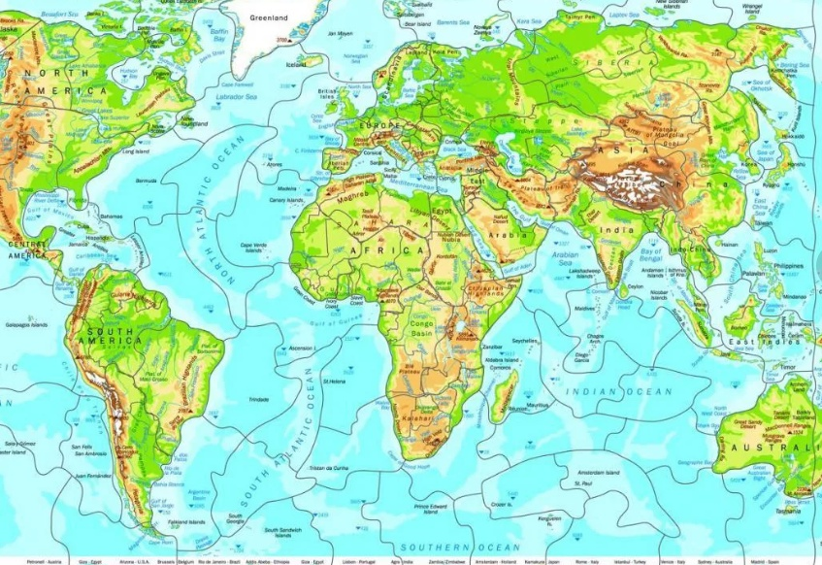

4. The sixth task. Write the names of the territories on the map:

Western Australia
Northen Territory
South Australia
Queensland
New South Wales

5. Let’s do the next task. Translate the sentences into English – first read the Russian variant, then – the translation.
- Большая часть населения – англичане по происхождению.
The population is mainly English in background.
- Английский – основной язык, на котором говорят австралийцы, но один из пяти австралийцев также говорит на итальянском, греческом, арабском, китайском или испанском.
English is the main language spoken, but one in five Australians speak also Italian, Greek, Arabic, Lebanese, Chinese or Spanish.
- Средиземноморский климат, галереи, музеи, архитектура и парки привлекают туристов в Сидней.
Mediterranean climate, galleries, museums, architecture and parks attract tourist to Sydney.

6.Label each picture.
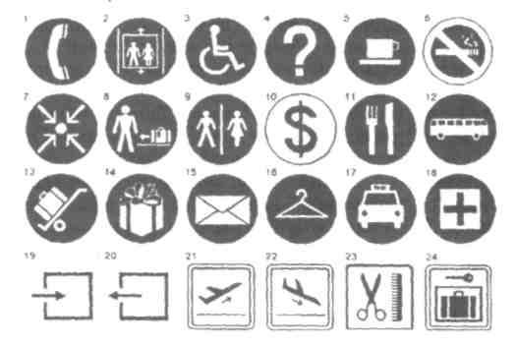

1.Telephone. 2. Elevator. 3. Facility for the disabled. 4. Information.
5. Cafe. 6.No smoking. 7. Meeting point. 8. Baggage claim. 9. Restrooms.
10. Exchange. 11.Restaurant. 12. Bus. 13. Porters. 14. Souvenirs. 15. Post office.
16. Check-room. 17.Taxi. 18. First aid. 19. Entrance. 20. Exit. 21. Departures.
22. Arrivals. 23. Hairdresser. 24. Luggage lockers.

7. Test your memory. Do the crossword puzzle.
Across:
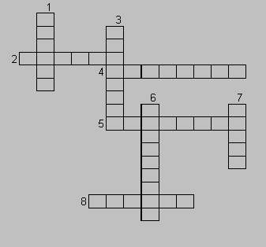
2. Tropical climate. Population 70 000. Capital of Nothern Territory.
4. Tropical climate makes this city a year-round vacation place
5. An industrial city. Population about 1 million.
8. Australia’s oldest and largest city.
Down:
1. Capital of Australian island-state of Tasmania. Cold winters.
3. Capital of Australia. Hosted 1956.
6. 2nd largest city of Australia. Hosted 1956 Olympics.
7. It has one of the best climates in Australia. Capital of Western Australia.
Key:
- Hobart.
- Darwin.
- Canberra.
- Brisbane.
- Adelaide.
- Melbourne.
- Perth.
- Sydney.
8The last task. Choose the right answer.
1. What is the capital of Australia?
- Sydney;
- Melbourne;
- Canberra.
2. When did Europeans settle in Australia?
- 1488;
- 1788;
- 1492;
- 1901.
3. Which is/ are a popular Australian animal(s)?
- Koala;
- Kangaroo;
- Emu;
- All of the above.
4. Which two animals can you see on the Australian coat of arms?
- Kangaroo and Dingo;
- Koala and Parrot;
- Kangaroo and Emu.
5. Which city is Australia’s oldest and largest?
- Sydney;
- Melbourne;
- Canberra.
6. Who are the Australian natives?
- Eskimos;
- Aborigines;
- Indians.
7. Who discovered Australia?
- Christopher Columbus;
- Captain Cook;
- Lewis and Clark.
8. Australia is not a (an)
- Country;
- Island;
- City;
- Continent.
9. Approximately how many nationalities live in Australia?
- 200;
- 20;
- 75;
- 5.
10. What is the official language in Australia?
- French;
- German;
- English.

Подведение итогов. Награждение победителей
-Are the jury ready to announce the results of the contests? (жюри оглашает результаты конкурсов и подводит итоги игры)
-Thank you for the game.
- Thanks to our jury for their work.
-We hope you’ve enjoyed the game. Good bye!

-The game is over.
The team № 1 has got …. points. The team № 2 has got …. points.
SO, THE WINNER IS …… Congratulations!

