Урок английского языкаКласс: 8
Тема урока: Sports in my life
Форма урока: комбинированный урок
Задачи урока:
- Познакомить учащихся с новой лексикой по теме «Спорт», тренировать ее в различных упражнениях.
- Развивать языковую компетенцию при формировании навыков чтения, аудирования и говорения.
- Способствовать развитию памяти, внимания, логики мышления.
- Способствовать воспитанию толерантности и интереса к стране изучаемого языка.
- Прививать любовь к спорту и здоровому образу жизни.
Оснащение урока:
- доска с датой и темой урока.
- транскрипционные значки для фонетической зарядки
- учебник

Ход урока
I.Организационный момент
-Good morning.
-I’m glad to see you.
-Take your seats, please.
-How are you today?
-Do you like sports?
-What kinds of sport do you know?
-What is your favourite kind of sports?
-And today the motto of our lesson is “Sports”. All together, please.
-Today we will speak about popular outdoor and indoor sports, the role of sport in our life.
-Now look up to the blackbord and name these spots and games

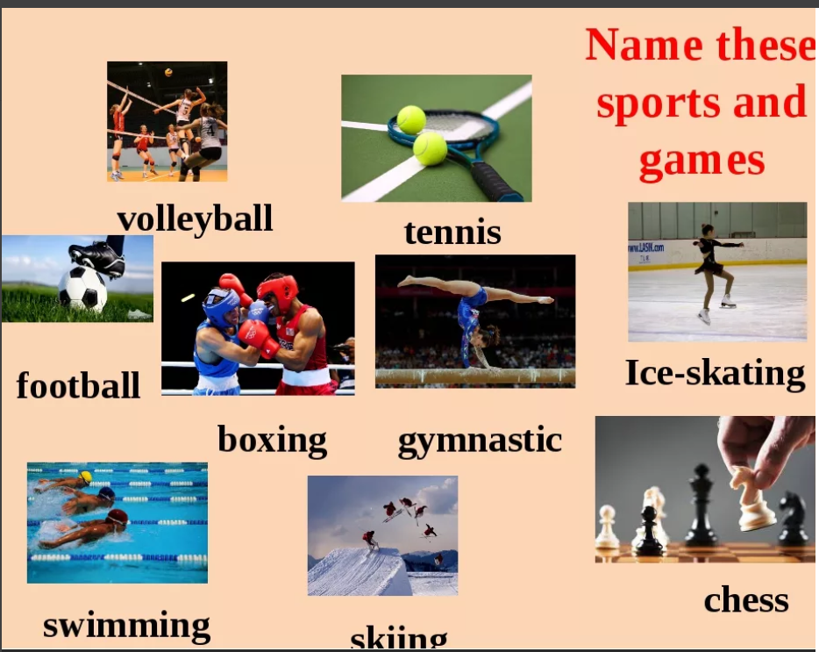

2.Речевая разминка
- Thousands years ago ancient Greeks said: “A sound mind is in a sound body.” Millions of people who go in for sports know from their own experience that this famous saying is true.
At the same time a great number of people don’t go in for sports. Some of them realize that sport is useful but prefer watching sport on TV to going in for it themselves.
Now I’d like to ask you some questions about sport and sport activities.
Do you take enough exercise? What exercise? How often do you go to the stadium? to the swimming bath?
What is your favourite pastime? Have you ever tried to do mountain climbing? When was it? Do you like playing football? Are you a member of the school team? Do you support your school team when they play?
Do you go in for sport? What sport? Does it thrill you to watch motor races? horse races? Do you know any favourite sportsmen or sportswomen?
Why is it necessary for teenagers to go in for sport?
What traditional Russian games do you know?
What sports and games are most popular in Russia now?
What sports are new or uncommon in our country?
What summer and winter sports do you know?
What sports would you enjoy most? Why?
What famous Russian and foreign athletes do you know? In what sports did they become famous?
What sports are the most dangerous and the least dangerous?
What water sports do you know?
Are there enough stadiums, gyms and swimming baths in the place where you live?

3. Фонетическая зарядка

First we repeat the words to the theme.

Match the words in English and in Russian.
Roller-skating | Катание на роликах
Skiing | Плавание
Swimming | Гибкий
Hiking | Велоспорт
Cycling | Катание на коньках
Skating | Катание на лыжах
Tournament | Горный туризм
Improve | Мускулы
Keep fit | Улучшать
Muscles | Турнир
Flexible | Быть в хорошей форме

4.Групповая работа
“Любимый вид спорта”
- Now I know that all you like sport and I’d like to find out the favourite kind of sport in your group. Interview your classmates, complete the table and report the results. Use the model:
Denis likes football .
Lena’s favourite sport is skiing.
(Учащиеся получают карточки с таблицей. В верхней строке учащиеся записывают имена участников своей группы. В беседе выявляют любимый вид спорта и отмечают в таблице. По образцу представитель от каждой группы сообщает о любимом виде спорта.

Football
rugby
Judo
Figer skating
ski halfpipe
Slopestyle
Skiing
Hockey
snowboard
Gymnastics
biathlon
Ice skating
Tennis
Basketball
Volleyball

5.Тренировочные лексические упражнения
1. Give the Russian equivalents for the following.
people all over the world, outdoor winter sports, shooting, hunting, tobogganing, figure-skating, excellent opportunities, go in for, gymnastics, track and field events, callisthenics, chess tournaments, essential part, weight lifting.
Give the English equivalents for the following.
зимние виды спорта, стрельба, хоккей, санный спорт, фигурное катание, прыжки с трамплина, прекрасные возможности, легкая атлетика, художественная гимнастика, шашки, шахматный турнир, тяжелая атлетика, гребля, гимнастика, плавательный бассейн.
2. Answer the questions, please.
- Are people all over the world fond of sports and games?
- What are the most popular outdoor winter sports?
- What do some people greatly enjoy?
- What game takes the first place?
- What other games are very popular?
- What do people go in for all the year round?
- What do young girls and women go in for?
- What indoor games are the most popular?
- What has become an essential part of people’s life?
- What is the biggest stadium in Moscow?
- Does sport help people to become stronger and healthier?

6.Аудирование

Угадать спортсмена

7. Match the sport and its name.
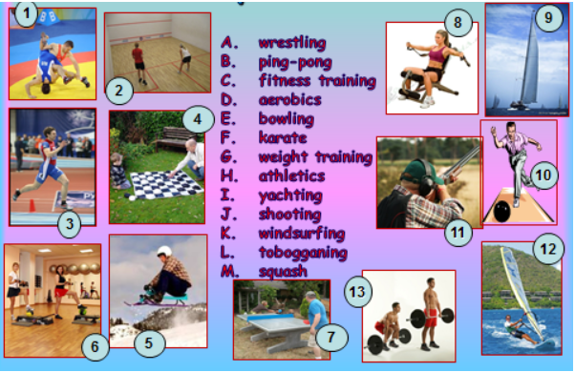

Рефлексия. Обучение монологической речи.
So, let's discuss our lessons.
How do you feel?
What have we learnt?
What do you know now?
You get good and excellent marks.
Домашнее задание. Подведение итогов урока. Выставление оценок.
-Your speaking was brilliant. You have worked well at the lesson. Now you can have a talk about sport. I’d like you can write about it. Your home task will be to do crossword puzzles or tests about Olympic Games. You must do some research and find out: kinds of sport, Character traits of the athlete, mascots and countries.
- I thank everybody for the lesson. You were very active. I hope this lesson was interesting for you and you have known much new and useful information. Thank you. The lesson is over. Good bye!

